|  |  |  |  |
| --- | --- | --- | --- |
| **Qualification Details** | | | |
| **Training Package Code & Title** | **UEE11 – Electrotechnology Training Package (Release 2.0)** | | |
| **Qualification National Code & Title** | **UEE40720 – Certificate IV in Electronics and**  **Communications** | **State code:** | **BFP4** |
| **UEE40120 – Certificate IV in**  **Computer Systems** | **BFL8** |
| **UEE50520 – Diploma of Electronics and**  **Communications Engineering** | **BFP5** |
| **UEE50120 – Diploma of**  **Computer Systems Engineering** | **BFQ6** |

|  |  |  |  |
| --- | --- | --- | --- |
| **Assessment Title** *(as per DAP)* | Portfolio 2- WLAN Design Site to site | **Location** | 10F80 |
| **Date Due** | Week 16 | **Date Received** |  |

|  |  |
| --- | --- |
| **Student Name** |  |
| **Student Declaration** | I declare that the evidence submitted is my own work: |

|  |  |  |  |  |
| --- | --- | --- | --- | --- |
| **Assessor Name** | **Haitham Khaled** | | | |
| **Assessment Decision** | Satisfactory | | Not Yet Satisfactory | |
| **Is student eligible for reassessment (Re-sit)?** | No | Yes | **Reassessment Date:** |  |
| **Assessor Signature** |  | | **Date** |  |

|  |  |  |  |
| --- | --- | --- | --- |
| **Feedback to student** | | | |
| See BB | | | |
| **Feedback from student** | | | |
|  | | | |
| **Student signature** |  | **Date** |  |

**Student Instructions**

This is a practical assessment. You will configure a wireless network and enable basic security using the commands in CLI using a 1252 Access Point. You will investigate selection of equipment, wireless parameters, performance, safety and regulations for a wireless network.

* Time Allocations: You will be given three hours to complete this task.
* Location of Assessment: In class
* Resources required: Computer, access to Internet, Access Point, cables, putty and Blackboard
* Adjustments to assessments may be made for you, providing the adjustments comply with the principles of assessment and rules of evidence.
* You must answer all nine questions satisfactorily. Answers must be provided for all sections that are highlighted by green. Answer in the space provided. Use a different color font so your answer stands out from the question. Submission must be through Black Board (BB).
* You must ensure that you have answered all parts of a question. You must include at least a paragraph for a 'briefly explain' question. One sentence will be deemed unsatisfactory.
* Feedback will be given through Black Board (BB). In case of not passing this assessment, you can re-sit for another assessment in Week 10 or 20 (the assessor will confirm with you the date).
* You may be asked verbal questions in class to prove authenticity and further proof of understanding of the submitted assessment.

**Preparation and OHS**

Students will be observed on the following throughout this assessment:

The following table (Table 1) contains:

Established OHS risk control measures and procedures in Electrotechnology.

Student Check Lists (please tick when you have completed the following)

|  |  |  |
| --- | --- | --- |
| **Assessment Criteria** | | |
| To be deemed satisfactory:  Answer all questions satisfactorily.  The following OHS checklist must be demonstrated by student. | | |
|  | **Student Check list** | **Observed** |
| OHS processes and procedures for Electrotechnology are followed. | Only used approved power packs. |  |
|  | Turn off power while making changes to a circuit connection. |  |
|  | Anti-static protection of ICs are followed. |  |
| Established OHS risk control measures and procedures in Electro-technology (Thornlie Campus) are followed. | Students are able to identify location of Circuit breakers |  |
|  | Hazards are identified and reported. |  |
|  | Unexpected situations are dealt with safely |  |
|  | Student awareness of First aid kit. |  |
|  | Students awareness First aid officer:  9267 7555 |  |
|  | Students awareness Campus Security: 9267 7666 |  |
|  | Work site cleaned, tools and equipment put away appropriately |  |
| Anti Discrimination legislation, regulations, polices and workplace procedures followed | Students completed all tasks while following all anti-discrimination legislation, regulations, policies and workplace procedures including using correct language when speaking to other students and lecturer and adhering to SM TAFE equity and diversity policy. |  |
| Sustainability principles followed | Students completed the task with minimum wastage and recycled components where possible. |  |
| Working with live power 240V  Students are strictly advised that they are not allowed to test/ measure 240 V without direct Lecturer supervision. | Students are observed that they disconnected power while modifying their Circuit. |  |

**As a Network technician, you are required to set up a wireless network connection between to two sites. In this task you will investigate and set up an Wireless Bridge to perform site to site connection between two campuses that are geographically apart. Your site to site wireless network will connect to your existing wireless network that you have designed in Portfolio 1.**

**Client Criteria:**

This assessment will be carried out as an industry simulation and where possible will reproduce and replicate the industry.

You are given a design specification of a wireless network. You are required to complete all 8 specification task for a site to site wireless design between Thornlie Campus and Midland Campus.

Answers must be provided for all sections that are highlighted by green.

**Specification Task 1**

**Specification Task 1: Pre-existing infrastructure**

Your site to site wireless network will connect to your existing wireless network that you have designed in Portfolio 1. Your wireless network will be an extension to existing network. An important step in network design is to examine a customer's existing network to determine how to meet expectations for network scalability, performance, and availability.

Requirements:

Using your site map that you have developed in Portfolio 1, show location of a Wireless Bridge and a directional Antenna that will provide you the capacity for your site to site connection.

**Specification Task 2: Installation Requirements (For Site to site)**

**Antenna Installation and safety**

Safety and other regulatory requirements to which the wireless network area shall comply are identified, obtained and understood.

Refer to the following site:

<https://www.acma.gov.au/our-rules-eme>

Identify safety and regulatory requirements when installing and using an Antenna for transmitting and receiving data.

Requirement 2a

Q1. Briefly explain how you could apply this to your wireless network design for site to site operation. Show location of your antenna for site to site.

Q2. What is the function of ARPANSA? Go to <https://www.arpansa.gov.au/regulation-and-licensing/regulatory-publications/radiation-protection-series/codes-and-standards/rps3>

to download Radiation Protection Standard for Maximum Exposure Levels to Radiofrequency Fields - 3 kHz to 300 GHz (2002).

Q3. Use the following site <https://www.acma.gov.au/our-rules-eme>

List three mobile devices with integral antenna to have safe EMF levels:

Q4. What steps must the suppliers of Wireless Devices must follow to meet Australian regulations. How could you insure the wireless devices that you intend to use in your design meets the ACMA regulations:

**Antenna installation for site to site:**

Requirement 2b

*Indicate clearly where your antennas are placed to cover area. List them in the Table given.*

Power

Indicate where a GPO is needed to power your MDF and IDFS. Think about power needs of your equipment. In case of power outage, what facilities should be included to avoid network coverage losses? Give one detailed solution.

Requirement 2c

*Indicate if you require a GPO. List where:*

Security

Task: What security measures (physical and logical) would you implement:

1. For your Wireless Bridge

2. MDFs

3. IDFs

4. Routers

5. Switches.

Requirement 2d

*Briefly explain for each:*

Environment

Task: What environment factors can cause networking equipment to fail. How would you protect your network against them?

Requirement 2e

*Briefly explain:*

**Specification Task 3: Location of MDF and IDF (AS needed for site to site connection)**

List distances between your MDF to IDF and IDF to IDF. List the type of LAN connection you have decided, speed and bandwidth requirements. Connections to servers (backbone cabling) will require high bandwidth connections.

Investigating architectural and environmental constraints:

Use the following table to help you answer:

|  |  |  |  |  |
| --- | --- | --- | --- | --- |
|  | Cable type | Length (m) | Speed | architectural and environmental constraints: |
| MDF1-IDF1 | Cat 5 | 50 | GB | Thick wall with metal re-enforcing. |
|  |  |  |  |  |

Show cable route between MDF and IDF with a dotted line.

*Requirement:*

*Use the information from this to fill up the given Template.*

**LAN Media**

Cable routes are planned to ensure maximum lengths specified by standards, manufactured to meet environments they are placed, perform suitably are not exceeded and regulatory requirements.

Draw a Rack to mount your Network equipment in your IDFs. Show location of your Networking equipment. Draw LAN cable connections between IDFS in your Drawing using red pen. Define the type of cable that you will use, for example, STP, UTP, Fiber Optics.

**Specification Task 4**

**Equipment selection and location**

List equipment to configure and provide wireless connection. Select an appropriate Wireless Bridge for your site to site connection. Does it meet the industrial standard for a college? Will it provide the appropriate Bandwidth? How do you ensure that it meets Australian safety requirements?

site to site Bridges

*Requirement 4a:*

* Briefly explain the following terms with reference to performance of Radio Signal and the effects of the environment:
* Attenuation
* Reflection
* Noise
* Dispersion
* Jitter
* What are some health and safety issues to consider with reference to working with Radio equipment?
* What regulatory body covers the use of wireless devices in Australia?

*Requirement 4a:*

*Select a Wireless bridge that is weatherproof, can run all day.*

*Show the locations of your Wireless Bridge in the main diagram and label it with an appropriate name.*

*Show the locations of an antenna for site to site coverage.*

*With a dotted line draw your cabling connections to these antenna from your Wireless Bridge.*

**Aerial cabling and earthing (for site to site)**

Download Australian Standard AS/ACIF S009:2006 Installation requirements for customer cabling (Wiring rules).

*Requirement 4b:*

Answer the following based on the standard:

1. According to Australian standard what is considered an aerial cabling?

2. According to the standard what is a communication earth system?

3. Briefly explain the reasons for EPR (Earth Potential Rise) and EPR hazard zone.

4. What is protective earth?

5. According to standard what are the requirements for earthing and bonding conductor?

6. Where a surge suppression device is installed, the total earthing conductor length between the surge suppression device and the main earthing bar, terminal or connection in the electrical switchboard should not exceed how many meters?

7. Indicate in your drawing the location of earthing bar. What is the preferred length of earthing cable for effective end user protection?

8. Earthing bar terminal should be capable of terminating conductors of what size?

**Specification Task 5 Network Map:**

Add equipment that you require for site to site WLAN to the Network Map that you have developed in Portfolio 1.

There are several aspects involved in characterizing the infrastructure of a network:

*Requirement:*

*Draw a flowchart of all Networking equipment and show how they are interconnected. You may use the Network map that you developed in Portfolio 1.*

**Specification Task 6- Set up Site to site connection:**

1.0 List the commands to erase the configuration file stored in your Wireless Bridge:

2.0 List the commands to set up BVI interface with the appropriate address.

3.0 List the steps to set up a host with appropriate address. How do you verify its connection to the wireless bridge?

4.0 List the steps to set up a GUI connection to your 1310 Bridge.

5.0 List the steps to set up a SSID and broadcast it.

6.0 Set up a site to site connection using two bridges in CLI mode. Provide evidence of configurations and verify your connection by taking screen shots of your outputs.

7.0 Only proceed after you have verified site to site connection (Access security)

Set up telnet:

Explain briefly what is a telnet connection and its purpose. Use Cisco.com or Cisco Wireless Curriculum to find out the commands to set up telnet connection. List the commands and verify your connection by taking screen shots of your outputs.

[list command here for telnet connection, use admin and cisco as username and password]

What are limitations of using telnet? How secure is telnet?

Setup SSH:

Explain briefly what is a SSH connection and its purpose. Use Cisco.com or Cisco Wireless Curriculum to find out the commands to set up SSH connection. List the commands and verify your connection by taking screen shots of your outputs.

[list command here for SSH connection, use admin and cisco as username and password]

**Specification Task 7:**

**Performance Requirements:**

1. Operating systems and protocols

*List the expected protocols and applications that are expected to run over your designed network.*

**Specification Task 8:**

**Site-to-site Survey**

*Requirement:*

*Using the Internet, find a topographical map that shows height contours of land between Thornlie and Midland. Briefly describe the terrain around Thornlie. Is there any hills or other major infrastructure that will inhibit wireless transmission to Midland campus? Insert a Screen Capture off the contour map here:*

*Note: to reduce the height of the required antenna masts you may want to go via SMTAFE at Bentley.*

You may want to use the following:

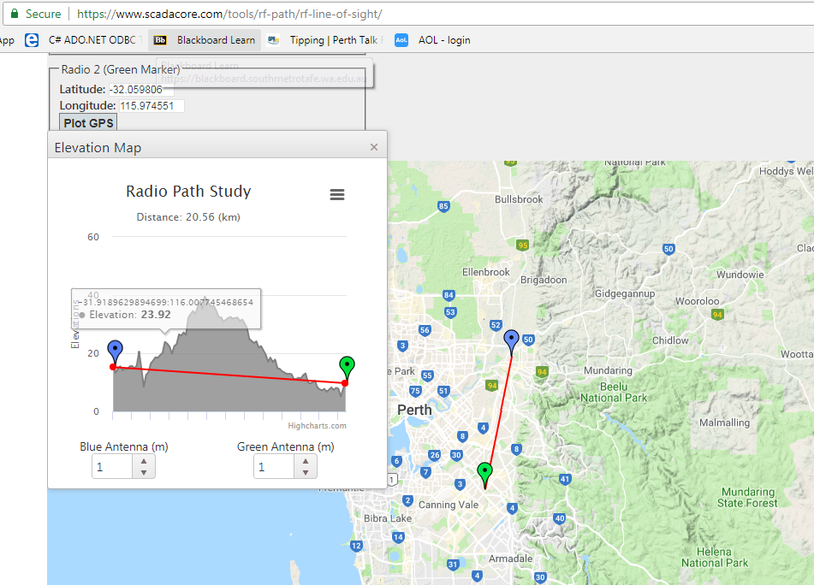

8.0 Provide an appropriate solution to an unplanned event such as major software/hardware failure of a Wireless Bridge configured above. How would you ensure that appropriate hardware/software are compatible and configurations restored to previous working state.

**End of Assessment**